# D.Y.PATIL COLLEGE OF ENGINEERING &TECHNOLOGY, KASABA BAWADA, KOLHAPUR

DEPARTMENT OF COMPUTER SCIENCE & ENGINEERING

(Academic Year: 2023-24)



**Submitted By:**

**REPORT**

On

**“Image to Text Translator”**

**Roll No. Name**

31 Miss. Siddhi Pravin Awasare

Under the Guidance of:

**Prof. A. S. Yadav**

## Class: **T.Y (CSE)** Div.: **“B”** Batch: **T2.**

# Index

|  |  |  |
| --- | --- | --- |
| Sr.no | Chapter | Pg.no |
| 1 | Introduction | 3 |
| 2 | Problem Statement | 4 |
| 3 | Objectives | 4 |
| 4 | Proposed System Architecture | 5 |
| 5 | Implementation | 6 |
| 6 | Conclusion | 7 |

# Introduction

# In today’s globalized world, communication knows no boundaries. Image To Text Translator, which redefines language translation. By effortlessly translating text from images, this transforms how we connect across cultures and languages.ImageText Translator empowers users with its instant text recognition technology. Using browser it selects image file and it provides accurate translations from images. Its user-friendly interface ensures seamless navigation, making it a must-have tool for diverse communication needs.

# Problem statement:

Existing graphical translation app lack real-time capabilities, causing delays in obtaining translations from images our goal is to develop a user-friendly mobile app that provides accurate and swift translations, addresssing the cahllenges faced due to language barrier.

# Objectives:

**1. Instant Translation:** Enable real-time translation of text from images, ensuring immediate understanding.

**2. User-Friendly Design**:The application should have a user-friendly interface that includes the following elements:

1. A "Browse Image" button to select an image file.
2. Labels to display "Original Text" and "Translated Text."
3. An option menu to select the target language**.**
4. Appropriate styling and layout to ensure a pleasant user experience.
5. **Multilingual Support:** Support a diverse range of languages, promoting global communication and inclusivity

**4.Error Handling:**The application should handle cases where the selected image cannot be processed or translated successfully, displaying appropriate error messages to the user

**Proposed system architecture:**

Start Image Capture &OCR Image processing

Optical Character

Extract Text

Translation API

Recognition

User Interface

* Display Captured Images.
* Display Recognized Text.
* Display Translation.

Translated Text

Fig. “Image Translator System Architecture”.

In above figure, shows the system architecture of Image Translator which operates through a user-friendly interface, capturing images processed by an Optical Character Recognition(OCR) module.The exatracted text undergoes translation and dispay the result.

**Implementation:**

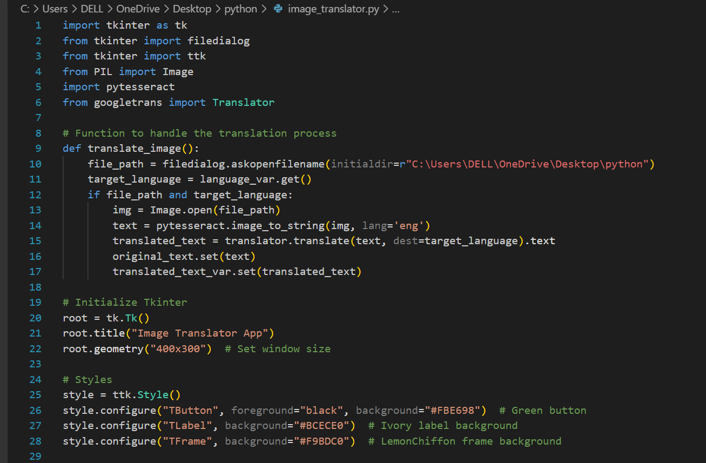

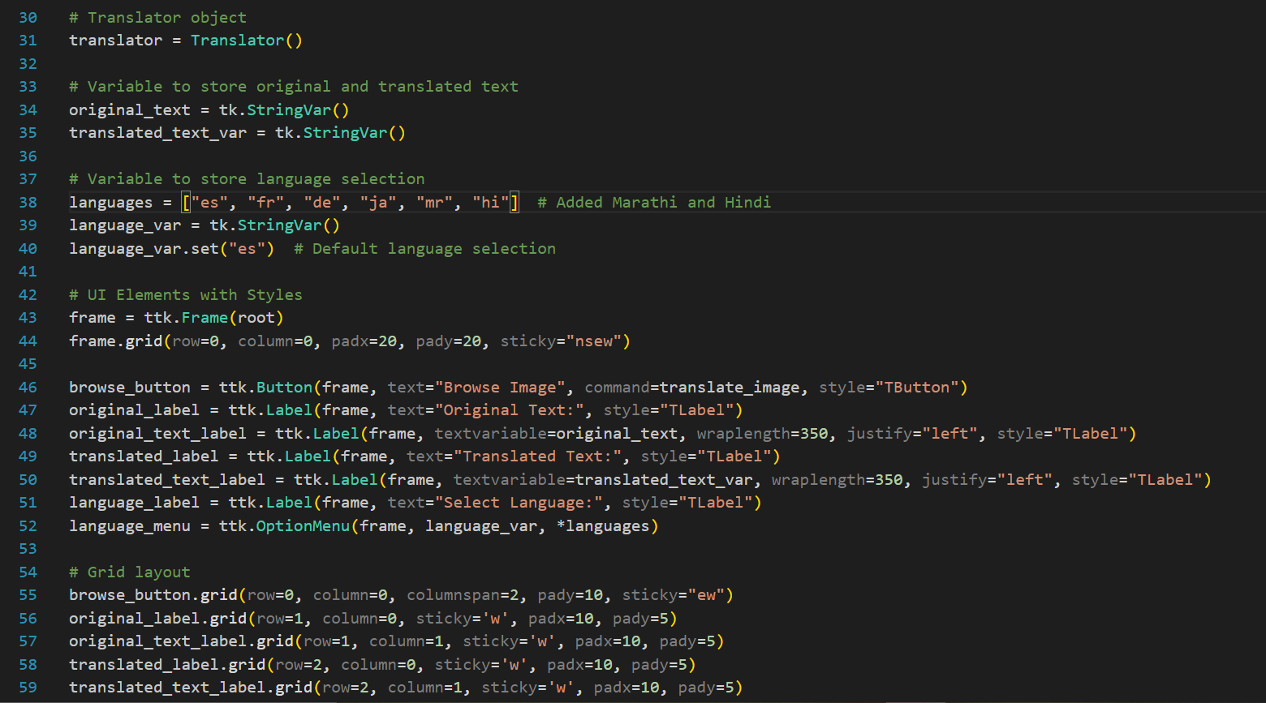

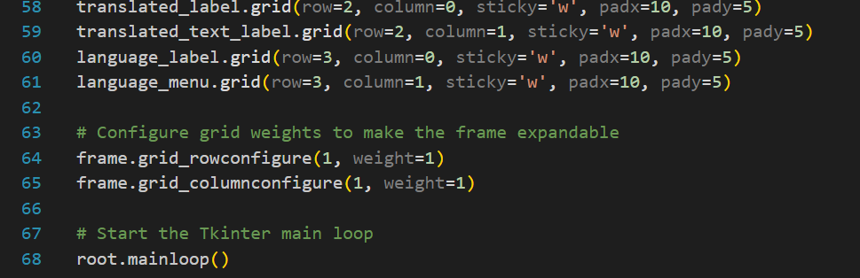

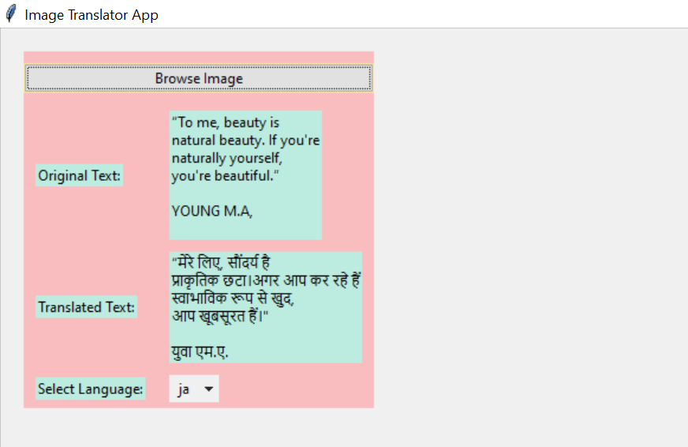

**Conclusion:**

In conclusion, Image to Text translator is a game-changer, making it easy for people from different languages to understand each other. With its smart technology, it translates text from images instantly. Whether you're traveling, learning, or working, this app ensures you can communicate effortlessly, promoting harmony and connection in our diverse global community.